

**Nike Dri-Fit T-Shirt (Junior/Men’s/Women’s)**

**Color: Royal Blue** with Logo

**$25** **Junior:** ☐Medium ☐Large ☐X-Large

**$30** **Men’s:** ☐X-Small ☐Small ☐Medium ☐Large

☐X-Large

**$30** **Women’s**: ☐X-Small ☐Small ☐Medium ☐Large

☐X-Large

***If you are ordering more than one shirt in the same size, please write the total number you are ordering above the size selected.***

**Nike Flow (looser fit) Dri-Fit Tank Top (Women’s)**

**Color: Grey** with Logo

**$30** **Adult:** ☐X-Small ☐Small ☐Medium

☐Large ☐X-Large

**2015**

**Harp Tennis T-Shirt/Tank Top Order Form**

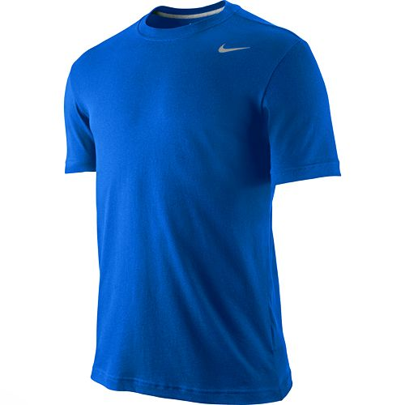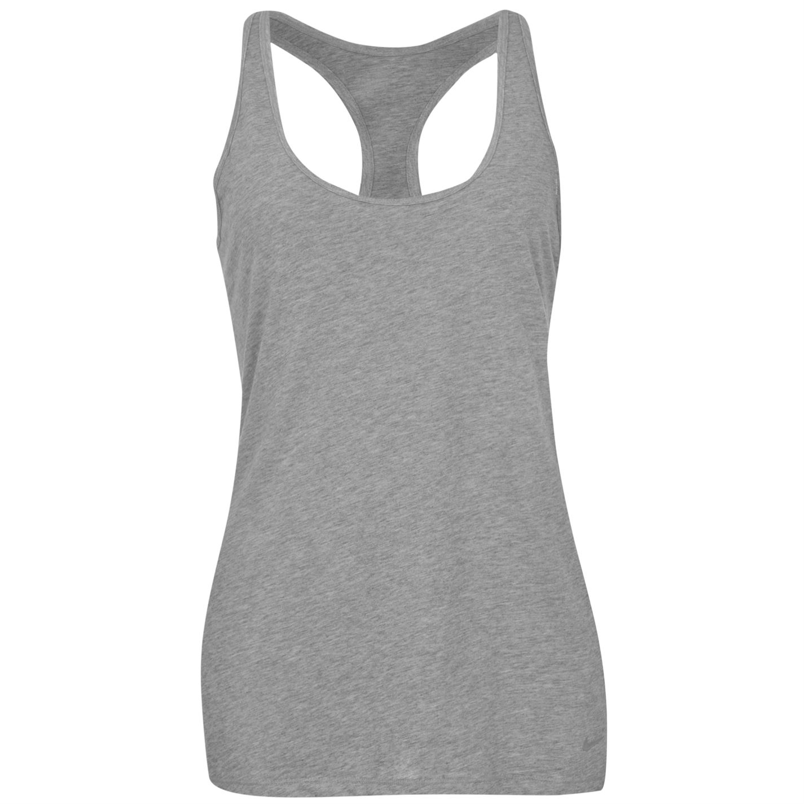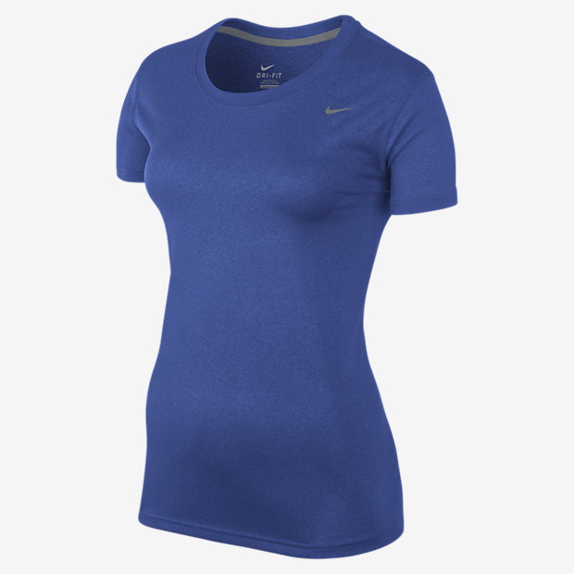

NAME_____________________________________________

TOTAL # OF JUNIOR T-SHIRTS ORDERED____________

TOTAL # OF ADULT T-SHIRTS ORDERED____________

TOTAL # OF WOMEN’S T-SHIRTS ORDERED____________

TOTAL # OF TANK TOPS ORDERED___________

TOTAL AMOUNT DUE___________

PAID CASH__________ PAID CHECK___________